Station #4-Chesepeake Colonies

Document #1- The History and Present State of Virginia, Robert Beverly, historian

“[This colony] was for the most part at first peopled by persons of low circumstances...Nor was it hardly possible it should be otherwise; for ‘tis not likely that any man of a plentiful estate should voluntarily abandon a happy certainty to roam after imaginary advantages in a New World. Besides which uncertainty, must have proposed to himself to encounter the infinite difficulties and dangers that attend a new settlement. These discouragements were sufficient to terrify any man that could live easy in England from going to...a strange land.”

Document #2- John Pray, Secretary of Virginia, Letter to Sir Dudley Carlton, 1619

“All our riches for the present doe consiste in Tobacco, wherein one man by his owne laboour hath in one yeare, raised to himself to value of 200 sterling; and another by the means of sixe servants hath cleared at one crop a thousand pound English.”

Document #3- Advertisement for auction of Virginia Tobacco in Liverpool, England

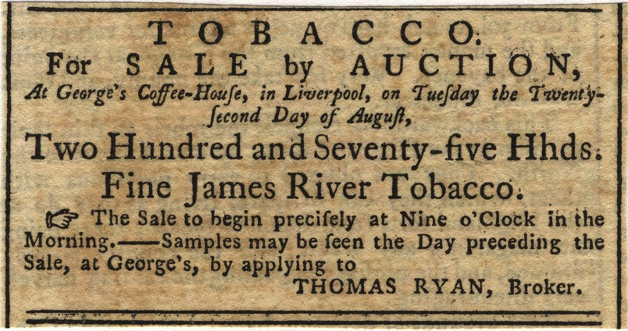

Document #4- An agent for the Virginia Company describing the Virginia colony, 1622

“I found the plantations generally seated upon mere salt marshes full of infectious bogs and muddy creeks and lakes, and thereby subjected to all those inconveniences and diseases which are so commonly found in the most unsound and most unhealthy parts of England”

Document #5- The Maryland Act of Toleration, 1649

“Be it therefore ordered and enacted...That whatsoever person or persons within this Province...shall henceforth blaspheme God, that is, curse Him or shall deny our Saviour Jesus Christ to be the Son of God, or shall deny the Holy Trinity.. Or the Godhead of any of the said Three persons of the Trinity or the Unity of the Godhead...shall be punished with death and confiscation or forfeiture of all his or her lands...And whereas… that no person or persons whatsoever within this province, or the islands, ports, harbors, creeks, or havens thereunto belonging professing to believe in Jesus Christ, shall from henceforth be any way troubled, molested or discounted for or in respect of his or her religion nor in free exercise thereof within this province of the islands thereunto belonging not any way compelled to the belief or exercise of any other Religion against his or her consent.”

Document #6- Virginia Laws for Blacks, 1619-1792

XXXIV. And if any slave resist his master, or owner, or other person, by his or her order, correcting such slave, and shall happen to be killed in such correction, it shall not be accounted felony, but the master, owner, and every such other person so giving correction, shall be free and acquit of all punishment and accusation for the same, as if such accident had never happened: And also, if any negro, mulatto, or Indian, bond or free, shall at any time, lift his or her hand, in opposition against any Christian, not being negro, mulatto, or Indian, he or she so offending, shall, for every such offence, proved by the oath of the party, receive on his or her bare back, thirty lashes, well laid on; Cognizable by a justice of the peace for that county wherein such offence shall be committed.

XXXVI. And also it is hereby enacted and declared, that baptism of slaves doth not exempt them from bondage; and that all children shall be bond or free, according to the condition of their mothers, and the particular directions of this act…

Document # 7- Ship’s List of Emigrants Bound for Virginia (July 1635)

These underwritten names are to be transported to Virginia, per examination by the minister of Gravesend touching their conformity to the Church discipline of England, and have taken the oaths of allegiance and supremacy:

Men
- Edward Towers- age 26
- Henry Woodman- age 22
- Richard Seems- age 26
- Vyncent Whatter- age 17
- James Whithedd- age 14
- Jonas Watts- age 21
- Peter Loe-age 33
- George Brocker- age 17
- Henry Eeles- age 26
- John Dennis- age 22
- John Exston-age 17
- William Luck- age 14
- John Tohams- age 19
- John Archer- age 21
- Martin Atkinson- age 32
- Edward Atkinson- age 28
- William Edwards- age 30
- Nathan Braddock- age 31
- Henry Carrell- age 16
- Gamaliel White- age 24
- Richard Marks- age 19
- Sam Jackson- age 24
- Allin King- age 19
- Rowland Sadler- age 19
- Joseph Phillips- age 28
- Daniel Endick- age 16
- Joseph Rowlidge- age 19
- Wiliam Westlie- age 40
- Joseph Smith- age 18
- Theodore Dodderidge- age 19
- Richard Williams- age 18
- Joseph Ballance- age 19
- William Baldin- age 21

Women
- Ann Swayne- age 22
- Elizabeth Cote- age 22
- Maudlin Lloyd- age 24
- Mabell Busher- age 14
- Mary Hawkes- age 19
- Ellin Hawkes- age 18

